Jalen Powell

July 28, 2021

Bio 103

Case Study 03

Part I:

1. The symptoms that are similar between Matthew and Samuel and any genetic disease background in family.
2. “Failure to Thrive” is meaning the inadequate growth or inability to grow at a young age.
3. Some reasons that newborns fail to survive are brain/nervous system damage, heart or lung problems, anemia, gastrointestinal issues
4. The weird smell coming from the baby’s diaper was a symptom of his sickness.

Part II:

1. 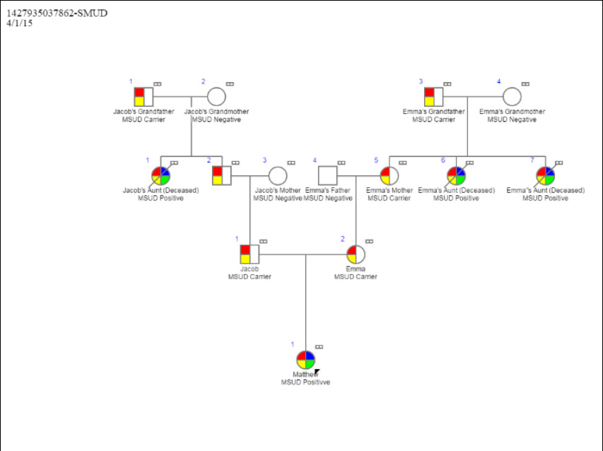
2. Genotype: the genetic constitution of an individual organism.

Phenotype: the set of observable characteristics of an individual resulting from the interaction of its genotype with the environment.

Homozygous: having two identical alleles of a particular gene or genes.

Heterozygous: having two different alleles of a particular gene or genes.

1. The parents were the carriers of it even though they don’t suffer from it.
2. The probability of Jacob and Emma’s child is ¼ chance of disease and 2/4 chances of carriers.
3. There is a 25% that Jacob and Emma will have a child without MSUD.
4. If the disease was dominant, then Matthew would inherit is 100%. Not just him, even his parents would also been affected.